**Thermodynamics**

Spontaneous and Nonspontaneous Processes have a natural tendency to occur in one direction under a given set of conditions. Water will naturally flow downhill, but uphill flow requires outside intervention such as the use of a pump. Iron exposed to the earth’s atmosphere will corrode, but rust is not converted to iron without intentional chemical treatment. A spontaneous process is one that occurs naturally under certain conditions. A non-spontaneous process, on the other hand, will not take place unless it is“driven ” by the continual input of energy from an external source. A process that is spontaneous in one direction under a particular set of conditions is nonspontaneous in the reverse direction. At room temperature and typical atmospheric pressure, for example, ice will spontaneously melt, but water will not spontaneously freeze. The spontaneity of a process is not correlated to the speed of the process. A spontaneous change may be so rapid that it is essentially instantaneous or so slow that it cannot be observed over any practical period of time. To illustrate this concept, consider the decay of radioactive isotopes, a topic more thoroughly treated in the chapter on nuclear chemistry. Radioactive decay is by definition a spontaneous process in which the nuclei of unstable isotopes emit radiation as they are converted to more stable nuclei. All the decay processes occur spontaneously, but the rates at which different isotopes decay vary widely. Technetium-99m is a popular radioisotope for medical imaging studies that undergoes relatively rapid decay and exhibits a half-life of about six hours. Uranium-238 is the most abundant isotope of uranium, and its decay occurs much more slowly, exhibiting a half-life of more than four billion years (Figure 16.2).

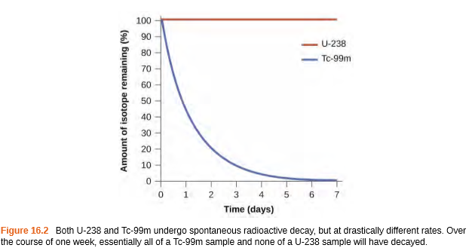

As another example, consider the conversion of diamond into graphite

The phase diagram for carbon indicates that graphite is the stable form of this element under ambient atmospheric pressure, while diamond is the stable allotrope at very high pressures, such as those present during its geologic formation. Thermodynamic calculations of the sort described in the last section of this chapter indicate that the conversion of diamond to graphite at ambient pressure occurs spontaneously, yet diamonds are observed to exist, and persist, under these conditions. Though the process is spontaneous under typical ambient conditions, its rate is extremely slow, and so for all practical purposes diamonds are indeed “forever.” Situations such as these emphasize the important distinction between the thermodynamic and the kinetic aspects of a process. In this particular case, diamonds are said to be thermodynamically unstable but kinetically stable under ambient conditions.

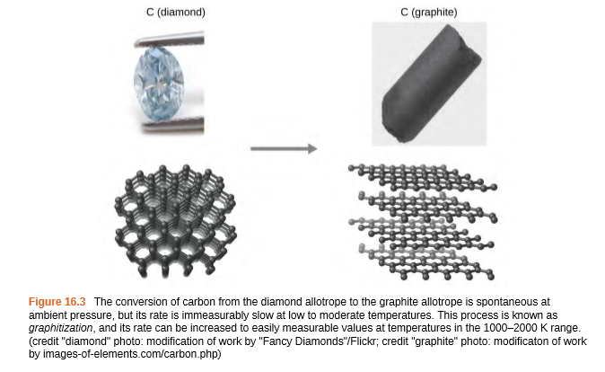

**Dispersal of Matter and Energy**

As we extend our discussion of thermodynamic concepts toward the objective of predicting spontaneity, consider now an isolated system consisting of two flasks connected with a closed valve. Initially there is an ideal gas on the left and a vacuum on the right (Figure 16.4). When the valve is opened, the gas spontaneously expands to fill both flasks. Recalling the definition of pressure-volume work from the chapter on thermochemistry, note that no work has been done because the pressure in a vacuum is zero.

w=−PΔV =0 (P=0 in a vacuum)

Note as well that since the system is isolated, no heat has been exchanged with the surroundings (q=0). The first law of thermodynamics confirms that there has been no change in the system’s internal energy as a result of this process

ΔU =q+w=0+0=0

Thespontaneityofthisprocessisthereforenotaconsequenceofanychangeinenergythataccompanies the process. Instead, the driving force appears to be related to the greater, more uniform dispersal of matter that results when the gas is allowed to expand. Initially, the system was comprised of one flask containing matter and another flask containing nothing. After the spontaneous process took place, the matter was distributed both more widely (occupying twice its original volume) and more uniformly (present in equal amounts in each flask).

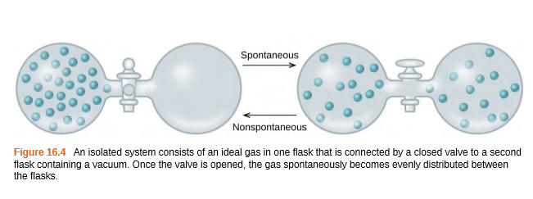

Now consider two object X at temperature TX and object Y at temperature TY, with TX > TY (Figure 16.5). When these objects come into contact, heat spontaneously flows from the hotter object (X) to the colder one (Y). This corresponds to a loss of thermal energy by X and a gain of thermal energy by Y.

qX <0 and qY =−qX >0

From the perspective of this two-object system, there was no net gain or loss of thermal energy, rather the available thermal energy was redistributed among the two objects. This spontaneous process resulted in a more uniform dispersal of energy.

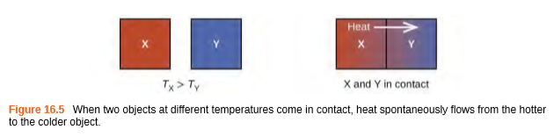

**Entropy**

In 1824, at the age of 28, Nicolas Léonard Sadi Carnot (Figure 16.7) published the results of an extensive study regarding the efficiency of steam heat engines. In a later review of Carnot’s findings, Rudolf Clausius introduced a new thermodynamic property that relates the spontaneous heat flow accompanying a process to the temperature at which the process takes place. This new property was expressed as the ratio of the reversible heat(qrev) and the kelvin temperature (T). The term reversible process refers to a process that takes place at such a slow rate that it is always at equilibrium and its direction can be changed (it can be “reversed”) by an infinitesimally small change is some

condition. Note that the idea of a reversible process is a formalism required to support the development of various thermodynamic concepts; no real processes are truly reversible, rather they are classified as irreversible. Similar to other thermodynamic properties, this new quantity is a state function, and so its change depends only upon the initial and final states of a system. In 1865, Clausius named this property entropy (S) and defined its change for any process as the following:



The entropy change for a real, irreversible process is then equal to that for the theoretical reversible process that involves the same initial and final states.

**Predicting the Sign of ΔS**

The relationships between entropy, microstates, and matter/energy dispersal described previously allow us to make generalizations regarding the relative entropies of substances and to predict the sign of entropy changes for chemical and physical processes. Consider the phase changes illustrated in Figure 16.10. In the solid phase, the atoms or moleculesarerestrictedtonearlyfixedpositionswithrespecttoeachotherandarecapableofonlymodestoscillations about these positions. With essentially fixed locations forth system’s component particles, the number of microstates is relatively small. In the liquid phase, the atoms or molecules are free to move over and around each other, though they remain in relatively close proximity to one another. This increased freedom of motion results in a greater variation in possible particle locations, so the number of microstates is correspondingly greater than for the solid. As a result, S liquid >S solid and the process of converting a substance from solid to liquid (melting) is characterized by an increase in entropy, ΔS > 0. By the same logic, the reciprocal process (freezing) exhibits a decrease in entropy, ΔS < 0

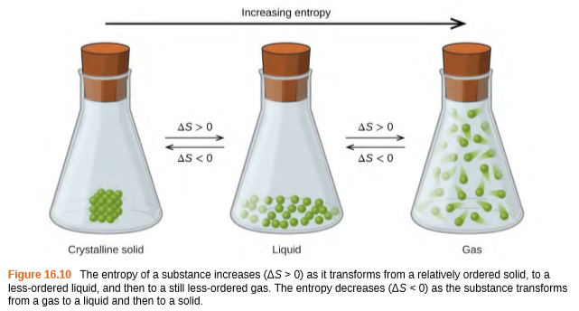

Now consider the vapor or gas phase. The atoms or molecules occupy a much greater volume than in the liquid phase; therefore, each atom or molecule can be found in many more locations than in the liquid (or solid) phase. Consequently, for any substance, S gas > S liquid > S solid, and the processes of vaporization and sublimation likewise involve increases in entropy, ΔS>0. Likewise, the reciprocal phase transitions, condensation and deposition, involve decreases in entropy, ΔS< 0.

According to kinetic-molecular theory, the temperature of a substance is proportional to the average kinetic energy of its particles. Raising the temperature of a substance will result in more extensive vibrations of the particles in solids and more rapid translations of the particles in liquids and gases. At higher temperatures, the distribution of kinetic energies among the atoms or molecules of the substance is also broader (more dispersed) than at lower temperatures. Thus, the entropy for any substance increases with temperature (Figure 16.11).

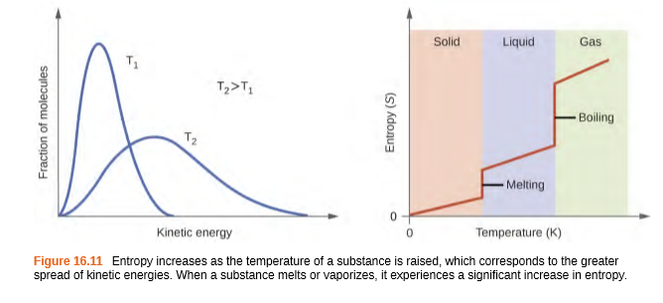

The entropy of a substance is influenced by structure of the particles (atoms or molecules) that comprise the substance. With regard to atomic substances, heavier atoms possess greater entropy at a given temperature than lighter atoms, which is a consequence of the relation between a particle’s mass and the spacing of quantized translational energy levels (which is a topic beyond the scope of our treatment). For molecules, greater numbers of atoms (regardless of their masses) increase the ways in which the molecules can vibrate and thus the number of possible microstates and the system entropy. Finally, variations in the types of particles affects the entropy of a system. Compared to a pure substance, in which all particles are identical, the entropy of a mixture of two or more different particle types is greater. This is because of the additional orientations and interactions that are possible in a system comprised of non-identical components. For example, when a solid dissolve in a liquid, the particles of the solid experience both a greater freedom of motion and additional interactions with the solvent particles. This corresponds to a more uniform dispersal of matter and energy and a greater number of microstates. The process of dissolution therefore involves an increase in entropy, ΔS> 0. Considering the various factors that affect entropy allows us to make informed predictions of the sign of ΔS for various chemical and physical processes as illustrated in Example 16.3.

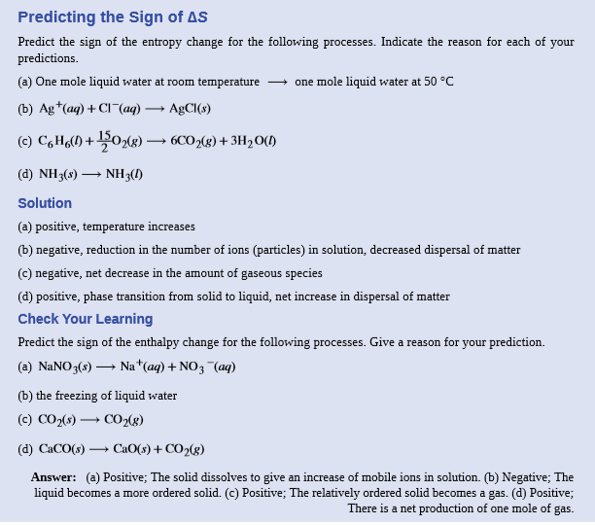

**The Second and Third Laws of Thermodynamics**

In the quest to identify a property that may reliably predict the spontaneity of a process, we have identified a very promising candidate: entropy. Processes that involve an increase in entropy of the system (ΔS > 0) are very often spontaneous; however, examples to the contrary are plentiful. By expanding consideration of entropy changes to include the surroundings, we may reach a significant conclusion regarding the relation between this property and spontaneity. In thermodynamic models, the system and surroundings comprise everything, that is, the universe, and so the following is true



To illustrate this relation, consider again the process of heat flow between two objects, one identified as the system and the other as the surroundings. There are three possibilities for such a process:

1. The objects are at different temperatures, and heat flows from the hotter to the cooler object. This is always observed to occur spontaneously. Designating the hotter object as the system and invoking the definition of entropy yields the following:



The arithmetic signs of qrev denote the loss of heat by the system and the gain of heat by the surroundings. Since T sys > Tsurr in this scenario, the magnitude of the entropy change for the surroundings will be greater than that for the system, and so the sum of ΔS sys and ΔSsurr will yield a positive value for ΔSuniv. This process involves an increase in the entropy of the universe.

2. The objects are at different temperatures, and heat flows from the cooler to the hotter object. This is never observed to occur spontaneously. Again designating the hotter object as the system and invoking the definition of entropy yields the following:



The arithmetic signs of qrev denote the gain of heat by the system and the loss of heat by the surroundings. The magnitude of the entropy change for the surroundings will again be greater than that for the system, but in this case,the signs of the heat changes will yield a negative value for ΔSuniv. This process involves a decrease in the entropy of the universe

3. The temperature difference between the objects is infinitesimally small, Tsys ≈ Tsurr, and so the heat flow is thermodynamically reversible. See the previous section’s discussion). In this case, the system and surroundings experience entropy changes that are equal in magnitude and therefore sum to yield a value of zero for ΔSuniv. This process involves no change in the entropy of the universe.

These results lead to a profound statement regarding the relation between entropy and spontaneity known as the second law of thermodynamics: all spontaneous changes cause an increase in the entropy of the universe. A summary of these three relations is provided in Table 16.1.

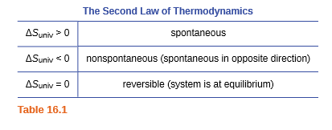

For many realistic applications, the surroundings are vast in comparison to the system. In such cases, the heat gained or lost by the surroundings as a result of some process represents a very small, nearly infinitesimal, fraction of its total thermal energy. For example, combustion of a fuel in air involves transfer of heat from a system (the fuel and oxygen molecules undergoing reaction) to surroundings that are infinitely more massive (the earth’s atmosphere). As a result, qsurr is a good approximation of qrev, and the second law may be stated as the following:



**The Third Law of Thermodynamics**

The previous section described the various contributions of matter and energy dispersal that contribute to the entropy of A system. With these contributions in mind, consider the entropy of a pure, perfectly crystalline solid possessing no kinetic energy (that is, at a temperature of absolute zero,0K). This system may be described by a single micro state, as its purity, perfect crystallinity and complete lack of motion means there is but one possible location for each identical atom or molecule comprising the crystal (W=1). According to the Boltzmann equation, the entropy of this system is zero.



This limiting condition for a system’s entropy represents the third law of thermodynamics: the entropy of a pure, perfect crystalline substance at 0 K is zero.

We can make careful calorimetric measurements to determine the temperature dependence of a substance’s entropy and to derive absolute entropy values under specific conditions. Standard entropies are given the label S298 ° for valuesdeterminedforonemoleofsubstanceatapressureof1barandatemperatureof298K.Thestandardentropy change (ΔS°) for any process may be computed from the standard entropies of its reactant and product species like the following:



Here, ν represents stoichiometric coefficients in the balanced equation representing the process. For example, ΔS° for the following reaction at room temperature





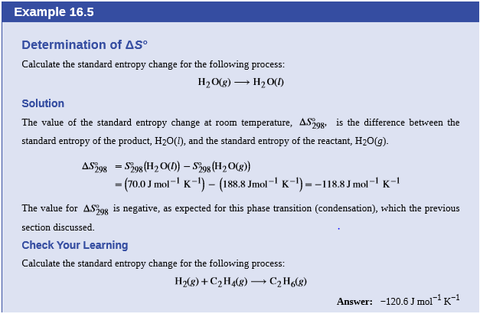

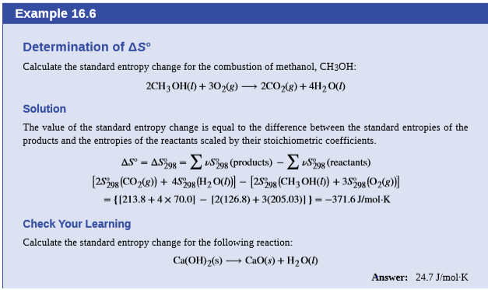

**Free Energy**

One of the challenges of using the second law of thermodynamics to determine if a process is spontaneous is that we must determine the entropy change for the system and the entropy change for the surroundings. An alternative approach involving a new thermodynamic property defined in terms of system properties only was introduced in the late nineteenth century by American mathematician Josiah Willard Gibbs. This new property is called the Gibbs free energy change (G) (or simply the free energy), and it is defined in terms of a system’s enthalpy and entropy as the following:

G= H−TS

Free energy is a state function, and at constant temperature and pressure, the standard free energy change (ΔG°) may be expressed as the following:

ΔG = ΔH−TΔS

(For simplicity’s sake, the subscript “sys” will be omitted henceforth.) We can understand the relationship between this system property and the spontaneity of a process by recalling the previously derived second law expression:



The first law requires that qsurr = −qsys, and at constant pressure qsys = ΔH, and so this expression may be rewritten as the following:



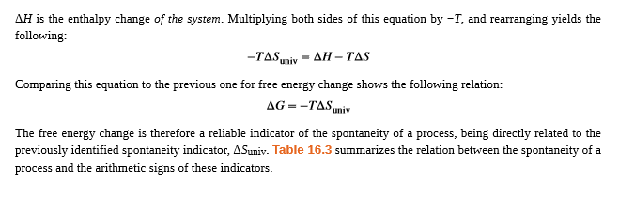

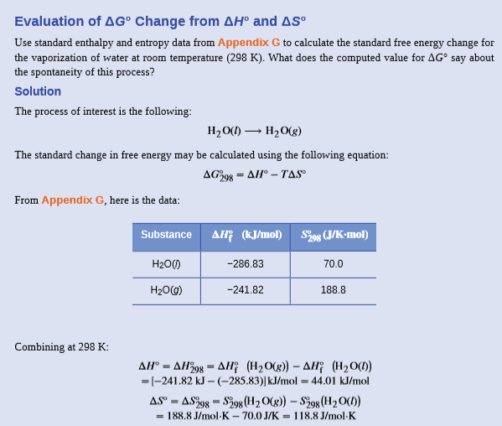

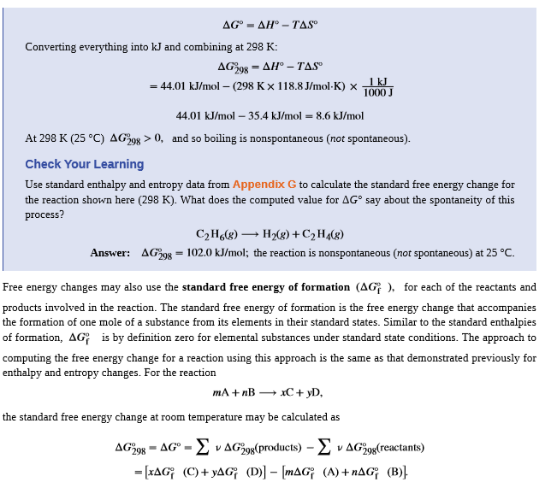

**Temperature Dependence of Spontaneity**

As was previously demonstrated in this chapter’s section on entropy, the spontaneity of a process may depend upon the temperature of the system. Phase transitions, for example, will proceed spontaneously in one direction or the other depending upon the temperature of the substance in question. Likewise, some chemical reactions can also exhibit temperature dependent spontaneities. To illustrate this concept, the equation relating free energy change to the enthalpy and entropy changes for the process is considered:

ΔG=ΔH−TΔS

The spontaneity of a process, as reflected in the arithmetic sign of its free energy change, is then determined by the signs of the enthalpy and entropy changes and, in some cases, the absolute temperature. Since T is the absolute (kelvin) temperature, it can only have positive values. Four possibilities therefore exist with regard to the signs of the enthalpy and entropy changes:

1. **Both ΔH and ΔS are positive.** This condition describes an endothermic process that involves an increase in system entropy. In this case, ΔG will be negative if the magnitude of the TΔS term is greater than ΔH. If the TΔS term is less than ΔH, the free energy change will be positive. Such a process is spontaneous at high temperatures and nonspontaneous at low temperatures.

2. **Both ΔH and ΔS are negative.** This condition describes an exothermic process that involves a decrease in system entropy. In this case, ΔG will be negative if the magnitude of the TΔS term is less than ΔH. If the TΔS term’s magnitude is greater than ΔH, the free energy change will be positive. Such a process is spontaneous at low temperatures and nonspontaneous at high temperatures.

3. **ΔH is positive and ΔS is negative**. This condition describes an endothermic process that involves a decrease in system entropy. In this case, ΔG will be positive regardless of the temperature. Such a process is nonspontaneous at all temperatures.

4. **ΔH negative and ΔS is positive.** This condition describes an exothermic process that involves an increase in system entropy. In this case, ΔG will be negative regardless of the temperature. Such a process is spontaneous at all temperatures.

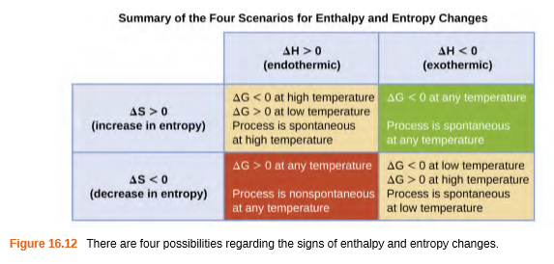

**Free Energy and Equilibrium**

The free energy change for a process may be viewed as a measure of its driving force. A negative value for ΔG represents a finite driving force for the process in the forward direction, while a positive value represents a driving force for the process in the reverse direction. When ΔG is zero, the forward and reverse driving forces are equal, and so the process occurs in both directions at the same rate (the system is at equilibrium).

In the chapter on equilibrium the reaction quotient, Q, was introduced as a convenient measure of the status of an equilibrium system. Recall that Q is the numerical value of the mass action expression for the system, and that you may use its value to identify the direction in which are action will proceed in order to achieve equilibrium. When Q is lesser than the equilibrium constant, K, there action will proceed in the forward direction until equilibrium is reached and Q=K. Conversely, if Q<K, the process will proceed in the reverse direction until equilibrium is achieved. The free energy change for a process taking place with reactants and products present under nonstandard conditions, ΔG, is related to the standard free energy change, ΔG°, according to this equation:

ΔG=ΔG°+RTlnQ

R is the gas constant (8.314J/Kmol), T is the kelvin or absolute temperature, and Q is the reaction quotient. We may use this equation to predict the spontaneity for a process under any given set of conditions as illustrated below

